**Ideation Phase**

**Brainstorm&Idea Prioritization Template**

|  |  |
| --- | --- |
| Date | 12-05-2023 |
| Team ID | NM2023TMID13133 |
| Project Name | AuditAI: A Machine Learning for Detecting Fraud in Audit Data |
| Maximum Marks | 4 Marks |

**Brainstorm & Idea Prioritization Template:**

**Our team Brainstorm & Idea Prioritization Template link:**

https://app.mural.co/invitation/mural/auditai0010/1682760022406?sender=u4c88650854b998c6b0516666&key=54b0299a-5565-4552-a3cf-18374c83e808

**Step-1: Team Gathering, Collaboration and Select the Problem Statement**

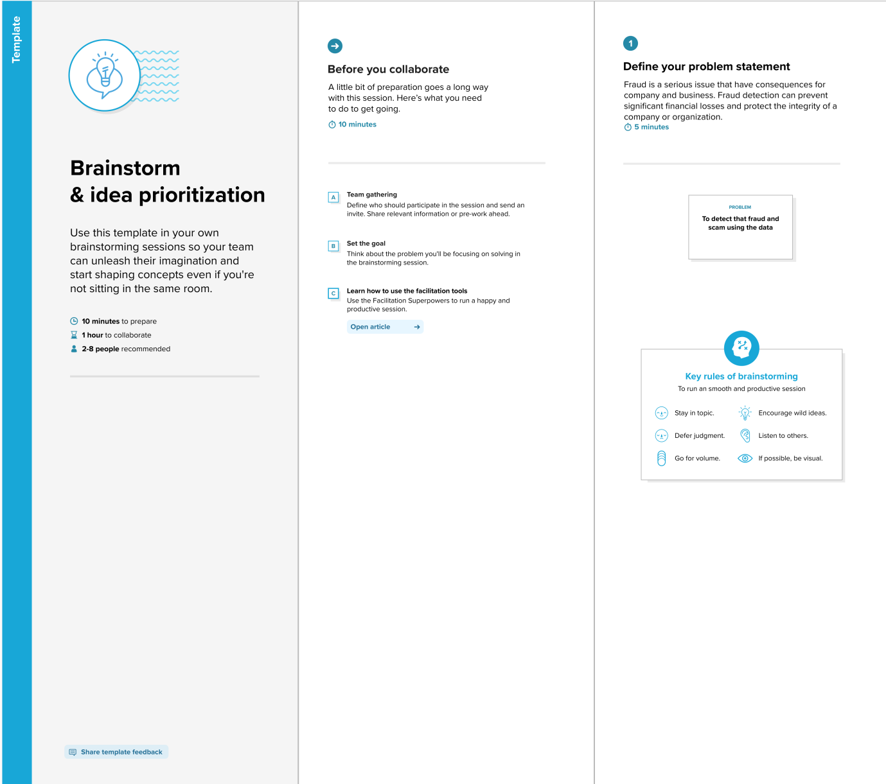

**Step-2: Brainstorm, Idea Listing and Grouping**

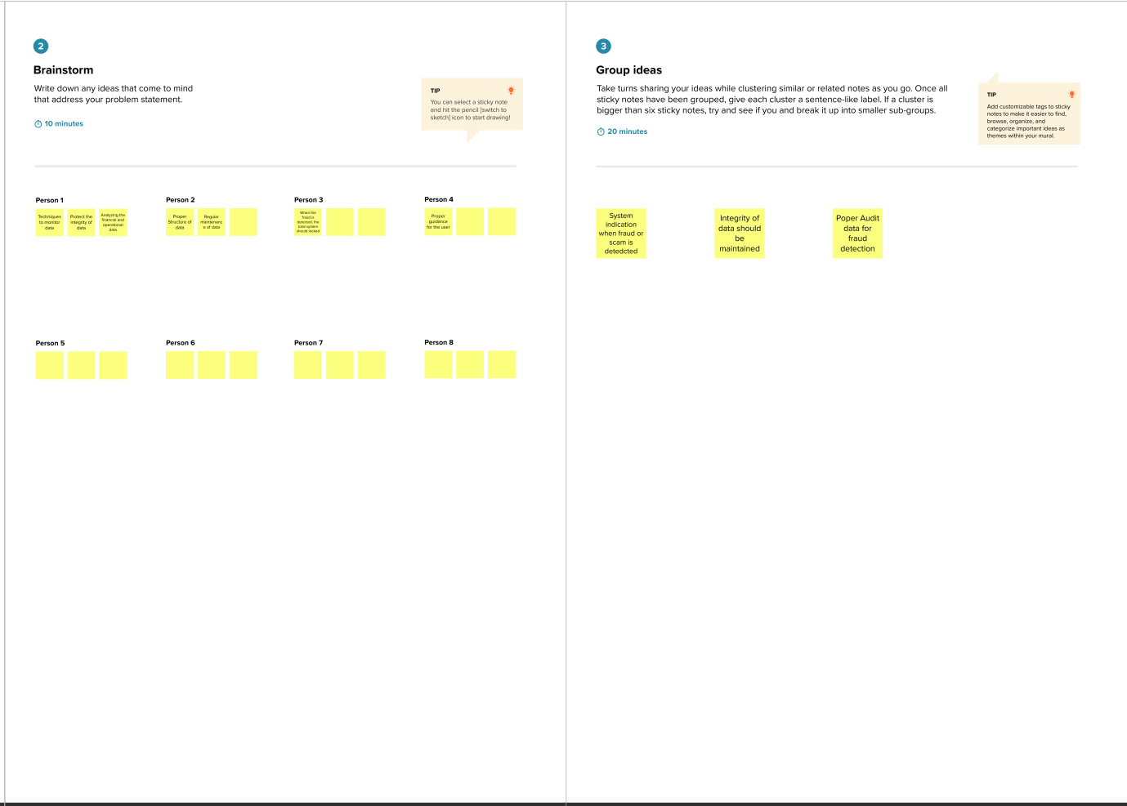

**Step-3: Idea Prioritization**

